**Week – 6 : Mandatory Hands on Exercises:**

**Skill: React Js**

**Hands on 1:**

**Step1:Installed create-react-app**

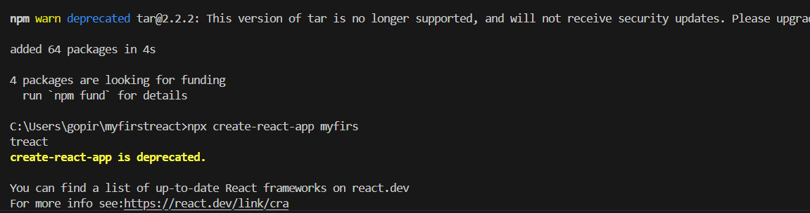

**Step 2:Created myfirstreactapp:**

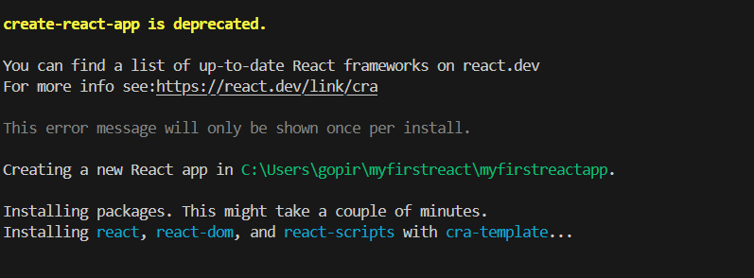

**Step 3**:After creating myfirstreactapp then replace the code in App.js as below

Function(){

Return(

<h1>Welcome the first session of React</h1>

);

}

**Output:at localhost:3000**

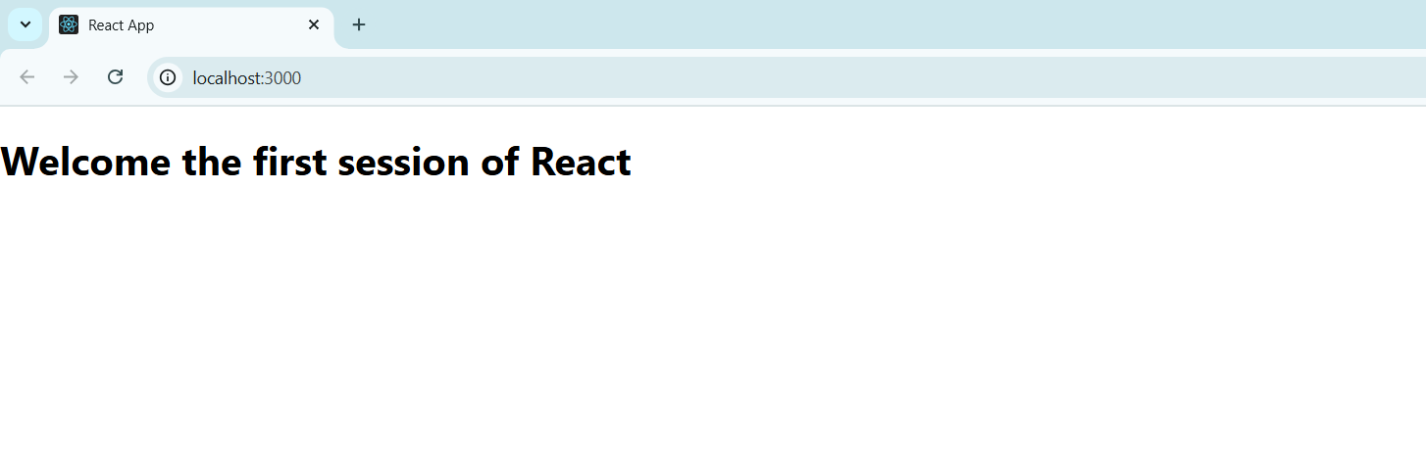

**Hands-on2:**

**Create a react app for Student Management Portal named StudentApp and create a component named Home which will display the Message “Welcome to the Home page of Student Management Portal”. Create another component named About and display the Message “Welcome to the About page of the Student Management Portal”. Create a third component named Contact and display the Message “Welcome to the Contact page of the Student Management Portal”. Call all the three components.**

**Step 1: create Components folder in Source:**

**Step 2:create Home File:**

import React,{Component} from 'react';

class Home extends Component{

    render(){

        return(

        <div>

        <h3>Welcome to the home page of student management portal</h3>

        </div>

        );

    }

}

export default Home;

**Step 3: Create Contact File:**

import React, { Component } from 'react';

class Contact extends Component {

    render() {

        return (

            <div>

                <h3>Welcome to the Contact page of the student management portal</h3>

            </div>

        );

    }

}

export default Contact;

**Step 3: Create About File:**

import React, { Component } from 'react';

class About extends Component {

    render() {

        return (

            <div>

                <h3>Welcome to the About page of the student management portal</h3>

            </div>

        );

    }

}

export default About;

**Step 4: Replace the code in App file:**

import logo from './logo.svg';

import './App.css';

import Home from './Components/Home';

import About from './Components/About';

import Contact from './Components/Contact';

function App(){

return (

  <div className="container">

    <Home/>

    <About/>

    <Contact/>

     </div>

);

}

export default App;

**Output:**

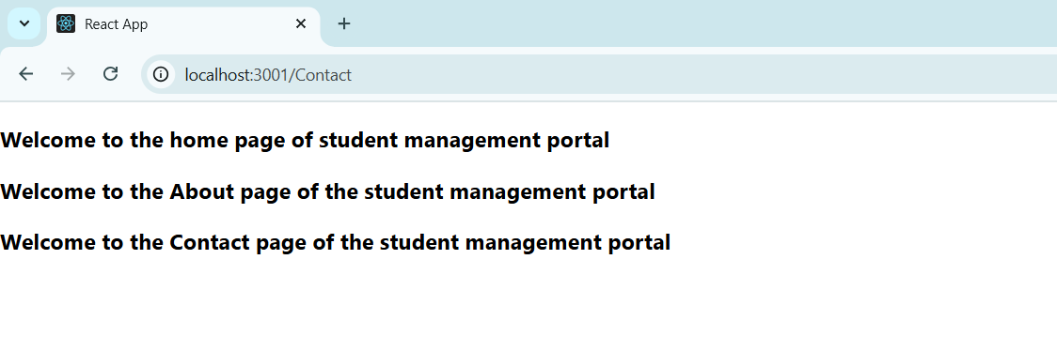

**Hands-on -3**:

**Create a react app for Student Management Portal named scorecalculatorapp and create a function component named “CalculateScore” which will accept Name, School, Total and goal in order to calculate the average score of a student and display the same.**

**Step 1:**

Create scorecalculator app using command npx create-react-app scorecalculaterapp**.**

**Step 2:**

**Create components folder in src and make CalculateScore.js file:**

import './Stylesheets/mystyle.css'

const percentToDecimal=(decimal)=>{

    return (decimal.toFixed(2)+'%')

}

const calcScore=(total,goal)=>{

    return percentToDecimal(total/goal)

}

export const CalculateScore=({Name,School,total,goal})=>{

    return(

    <div className="formatstyle">

        <h1><font color="Brown">Student Details:</font></h1>

        <div className="Name">

            <b><span>Name:</span></b>

            <span>{Name}</span>

        </div>

        <div className="School">

            <b><span>School:</span></b>

            <span>{School}</span>

        </div>

        <div className="Total">

            <b><span>Total:</span></b>

            <span>{total}</span>

            <span>Marks</span>

        </div>

        <div className="Score">

            <b>Score:</b>

            <span>

                {calcScore(

                    total,

                    goal

                )}

            </span>

        </div>

    </div>

    );

}

export default CalculateScore;

**Step 3:**

Create stylesheets folder and create mystyle.css file:

.Name{

    font-weight:300;

    color:blue;

}

.School{

    color:crimson ;

}

.Total{

    color:darkmagenta ;

}

.formatstyle{

    text-align:center;

    font-size:large;

}

.Score

{

    color:forestgreen ;

}

**Step 4: replace code in app.js file:**

import CalculateScore from './components/CalculateScore';

function App(){

  return(

    <div>

      <CalculateScore Name={"steeve"}

      School={"DNV Public Score"}

      total={284}

      goal={3}

      />

    </div>

  )

}

export default App;

**Output:**

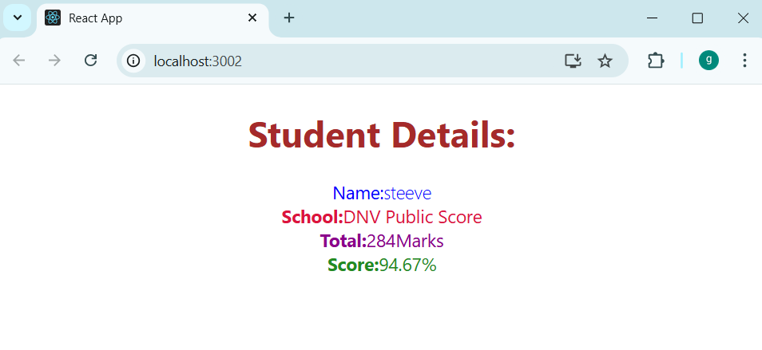

**Hands-on-4:blogapp:**

**Step 1:**

Create blogapp using the command npx create-react-app blogapp

**Step 2: create a post.js file**

import React from 'react';

class Post extends React.Component {

render() {

const { title, body } = this.props;

return (

<div style={{ border: '1px solid #ccc', padding: '15px', marginBottom: '10px' }}>

<h2>{title}</h2>

<p>{body}</p>

</div>

);

}

}

export default Post;

**Step 3:create posts.js file**

import React from 'react';

import Post from './Post';

class Posts extends React.Component {

constructor(props) {

super(props);

this.state = {

posts: [],

error: null,

};

}

async componentDidMount() {

console.log("Fetching posts...");

try {

const res = await fetch('https://jsonplaceholder.typicode.com/posts');

if (!res.ok) {

throw new Error(`Failed to fetch: ${res.status}`);

}

const data = await res.json();

console.log("Fetched data:", data.slice(0, 3)); // show 3 sample posts

this.setState({ posts: data });

} catch (err) {

console.error("Error fetching posts:", err);

this.setState({ error: "Unable to load posts. Try again later." });

}

}

componentDidCatch(error, info) {

console.error("Rendering error caught:", error, info);

alert("A rendering error occurred!");

}

render() {

const { posts, error } = this.state;

if (error) return <div style={{ color: 'red' }}>{error}</div>;

if (posts.length === 0) return <div>Loading posts...</div>;

return (

<div>

<h1>Posts</h1>

{posts.map(post => (

<Post key={post.id} title={post.title} body={post.body} />

))}

</div>

);

}

}

export default Posts;

**Step 4: modify app.js file**

import React from 'react';

import Posts from './Posts';

function App() {

return (

<div className="App" style={{ padding: '20px', maxWidth: '800px', margin: 'auto' }}>

<Posts />

</div>

);

}

export default App;

**output:**

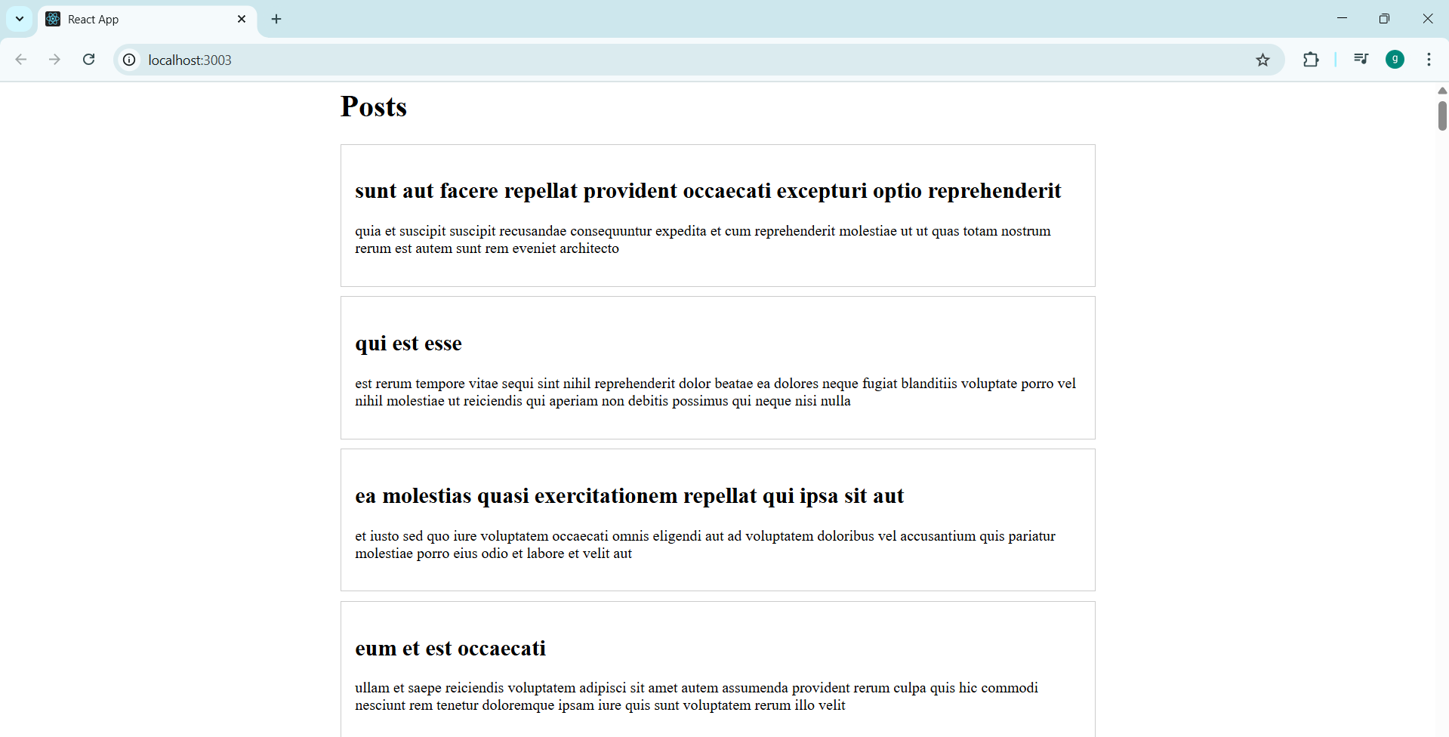

**Hands on 5:**

**Step 1:**

**Create cohortDetails.js file**

import React from 'react';

import styles from './CohortDetails.module.css';

function CohortDetails(props) {

const { name, trainer, status, startDate, endDate } = props;

const headingStyle = {

color: status.toLowerCase() === 'ongoing' ? 'green' : 'blue'

};

return (

<div className={styles.box}>

<h3 style={headingStyle}>{name}</h3>

<dl>

<dt>Trainer</dt>

<dd>{trainer}</dd>

<dt>Status</dt>

<dd>{status}</dd>

<dt>Start Date</dt>

<dd>{startDate}</dd>

<dt>End Date</dt>

<dd>{endDate}</dd>

</dl>

</div>

);

}

export default CohortDetails;

**Step 2:create cohortdetails.module.css file**

.box {

width: 300px;

display: inline-block;

margin: 10px;

padding: 10px 20px;

border: 1px solid black;

border-radius: 10px;

}

dt {

font-weight: 500;

}

**Step 3:modify App.js file**

import React from 'react';

import CohortDetails from './CohortDetails';

function App() {

return (

<div className="App">

<h1>Cohort Dashboard</h1>

<CohortDetails

name="React Bootcamp"

trainer="Alice"

status="ongoing"

startDate="2025-07-01"

endDate="2025-08-15"

/>

<CohortDetails

name="Java Fundamentals"

trainer="Bob"

status="completed"

startDate="2025-05-10"

endDate="2025-06-20"

/>

</div>

);

}

export default App;

**Step 4:Modify index.js file**

import React from 'react';

import ReactDOM from 'react-dom/client';

import App from './App';

import './index.css'; // optional

const root = ReactDOM.createRoot(document.getElementById('root'));

root.render(<App />);

**Output:**

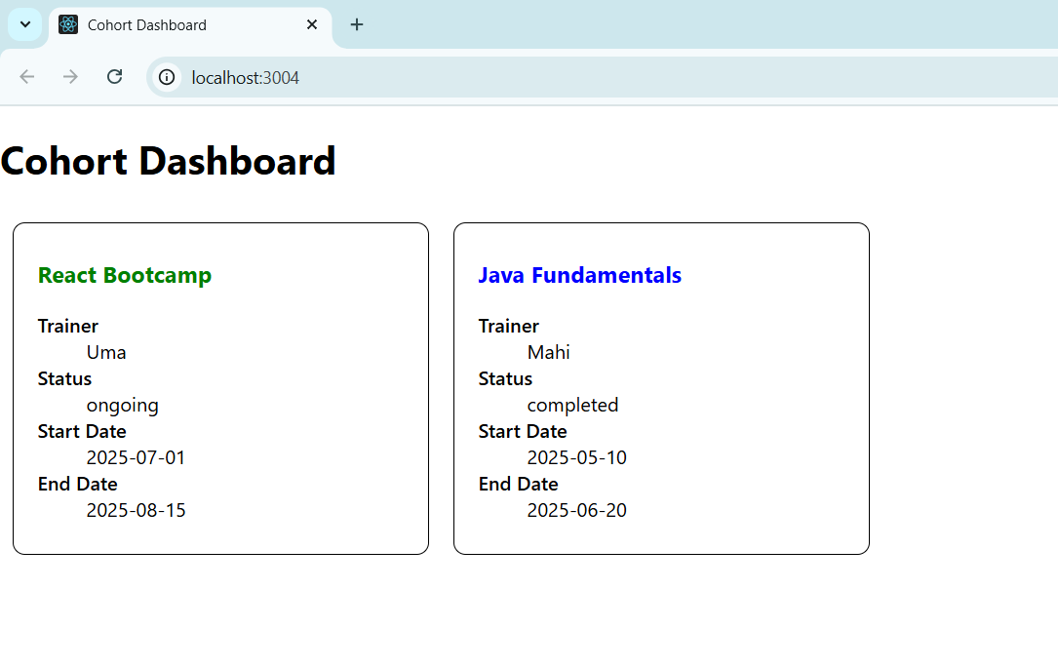

**Additional Important Hands on:**

**Hands on 6:**

**Cognizant Academy teams want to maintain a list of trainers along with their expertise in a SPA using React as the technology. You are assigned the task of creating this React app.**

**The following trainers’ data application will deal.**

1. **T-ID**
2. **Name**
3. **Phone**
4. **Email**
5. **Stream**
6. **Skills**

**Step 1:**

**Install router with command: npm install react-router-dom@6**

**Step 2:create react app as trainersapp**

**Step 3:modify index.js file**

import React from 'react';

import ReactDOM from 'react-dom/client';

import App from './App';

const root = ReactDOM.createRoot(document.getElementById('root'));

root.render(

<React.StrictMode>

<App />

</React.StrictMode>

);

**Step 4:Modify app.js file**

import React from 'react';

import { BrowserRouter as Router, Routes, Route, Link } from 'react-router-dom';

import Home from './Home';

import TrainerList from './TrainerList';

import TrainerDetails from './TrainerDetails';

import trainers from './TrainersMock';

function App() {

return (

<Router>

<div style={{ padding: '20px' }}>

<h1>TrainersApp</h1>

<nav>

<Link to="/" style={{ marginRight: '15px' }}>Home</Link>

<Link to="/trainers">Trainers</Link>

</nav>

<hr />

<Routes>

<Route path="/" element={<Home />} />

<Route path="/trainers" element={<TrainerList data={trainers} />} />

<Route path="/trainer/:id" element={<TrainerDetails />} />

</Routes>

</div>

</Router>

);

}

export default App;

**step 5:create Home.js file**

import React from 'react';

function Home() {

return (

<div>

<h2>Welcome to Cognizant Academy</h2>

<p>This is the Trainer Management System.</p>

</div>

);

}

export default Home;

**step 6:Create Trainer.js file**

class Trainer {

constructor(trainerId, name, email, phone, technology, skills) {

this.trainerId = trainerId;

this.name = name;

this.email = email;

this.phone = phone;

this.technology = technology;

this.skills = skills;

}

}

export default Trainer;

**step 7:create TrainersMock.js file**

import Trainer from './Trainer';

const trainers = [

  new Trainer(1, "Uma", "uma@example.com", "1234567890", "React", ["Hooks", "Redux"]),

  new Trainer(2, "Mahi", "mahi@example.com", "0987654321", "Angular", ["RxJS", "NgRx"]),

  new Trainer(3, "Chandhu", "chandu@example.com", "5556667777", "Vue", ["Vuex", "Composition API"]),

];

export default trainers;

**step 8:Create TrainerList.js file**

import React from 'react';

import { Link } from 'react-router-dom';

function TrainerList({ data }) {

return (

<div>

<h2>Trainers List</h2>

<ul>

{data.map(trainer => (

<li key={trainer.trainerId}>

<Link to={`/trainer/${trainer.trainerId}`}>{trainer.name}</Link>

</li>

))}

</ul>

</div>

);

}

export default TrainerList;

**Step 9:Create TrainerDetails.js file**

import React from 'react';

import { useParams } from 'react-router-dom';

import trainers from './TrainersMock';

function TrainerDetails() {

const { id } = useParams();

const trainer = trainers.find(t => t.trainerId === parseInt(id));

if (!trainer) {

return <div>Trainer not found.</div>;

}

return (

<div>

<h2>{trainer.name}</h2>

<p><strong>Email:</strong> {trainer.email}</p>

<p><strong>Phone:</strong> {trainer.phone}</p>

<p><strong>Technology:</strong> {trainer.technology}</p>

<p><strong>Skills:</strong> {trainer.skills.join(', ')}</p>

</div>

);

}

export default TrainerDetails;

**Output:**

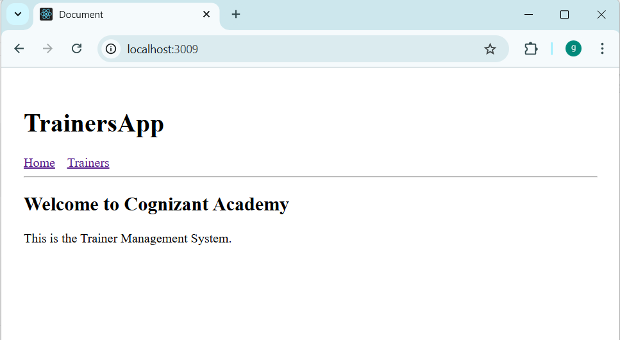

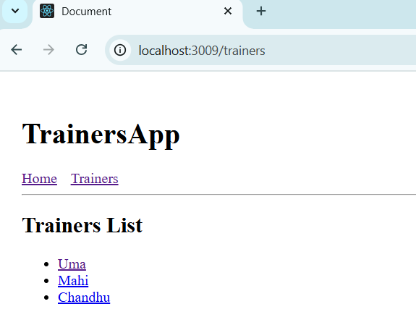

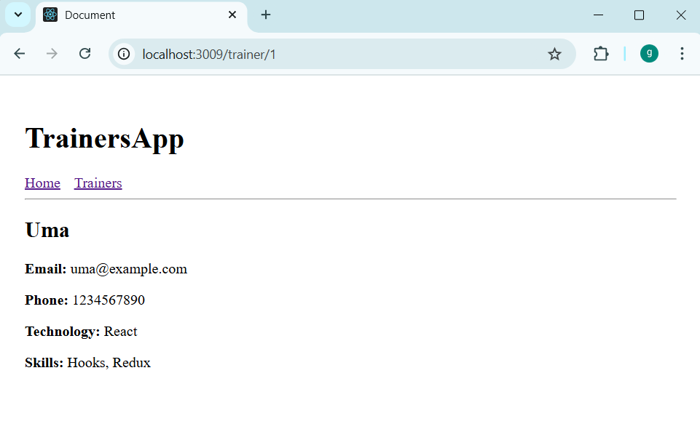

**Hands on 7:**

**Create a React Application named “shoppingapp” with a class component named “OnlineShopping” and “Cart”.**

**Step 1:**

**Create shoppingapp using command as “npx create-react-app shoppingapp”**

**Step 2:**

**Create a class of Cart (Modify index.js as below):**

import React from 'react';

import ReactDOM from 'react-dom/client';

import OnlineShopping from './App';

const root = ReactDOM.createRoot(document.getElementById('root'));

root.render(

<React.StrictMode>

<OnlineShopping />

</React.StrictMode>

);

**Step 3:**

**Create a class of online shopping(Modify react.js as below):**

import React from "react";

class Cart extends React.Component {

render() {

return (

<tr>

<td style={styles.cell}>{this.props.Itemname}</td>

<td style={styles.cell}>{this.props.Price}</td>

</tr>

);

}

}

class OnlineShopping extends React.Component {

constructor(props) {

super(props);

this.state = {

cartItems: [

{ Itemname: "Laptop", Price: 80000 },

{ Itemname: "TV", Price: 120000 },

{ Itemname: "Washing Machine", Price: 50000 },

{ Itemname: "Mobile", Price: 30000 },

{ Itemname: "Fridge", Price: 70000 }

]

};

}

render() {

return (

<div style={styles.container}>

<h2 style={styles.heading}>Items Ordered :</h2>

<table style={styles.table}>

<thead>

<tr>

<th style={styles.header}>Name</th>

<th style={styles.header}>Price</th>

</tr>

</thead>

<tbody>

{this.state.cartItems.map((item, index) => (

<Cart key={index} Itemname={item.Itemname} Price={item.Price} />

))}

</tbody>

</table>

</div>

);

}

}

const styles = {

container: {

textAlign: "center",

marginTop: "50px"

},

heading: {

color: "green",

fontWeight: "bold",

fontSize: "2em",

marginBottom: "30px"

},

table: {

margin: "0 auto",

borderCollapse: "collapse",

border: "2px solid green"

},

header: {

border: "2px solid green",

padding: "12px 20px",

color: "green",

fontWeight: "bold",

fontSize: "16px"

},

cell: {

border: "2px solid green",

padding: "12px 20px",

color: "green",

fontSize: "15px"

}

};

export default OnlineShopping;

**Output:**

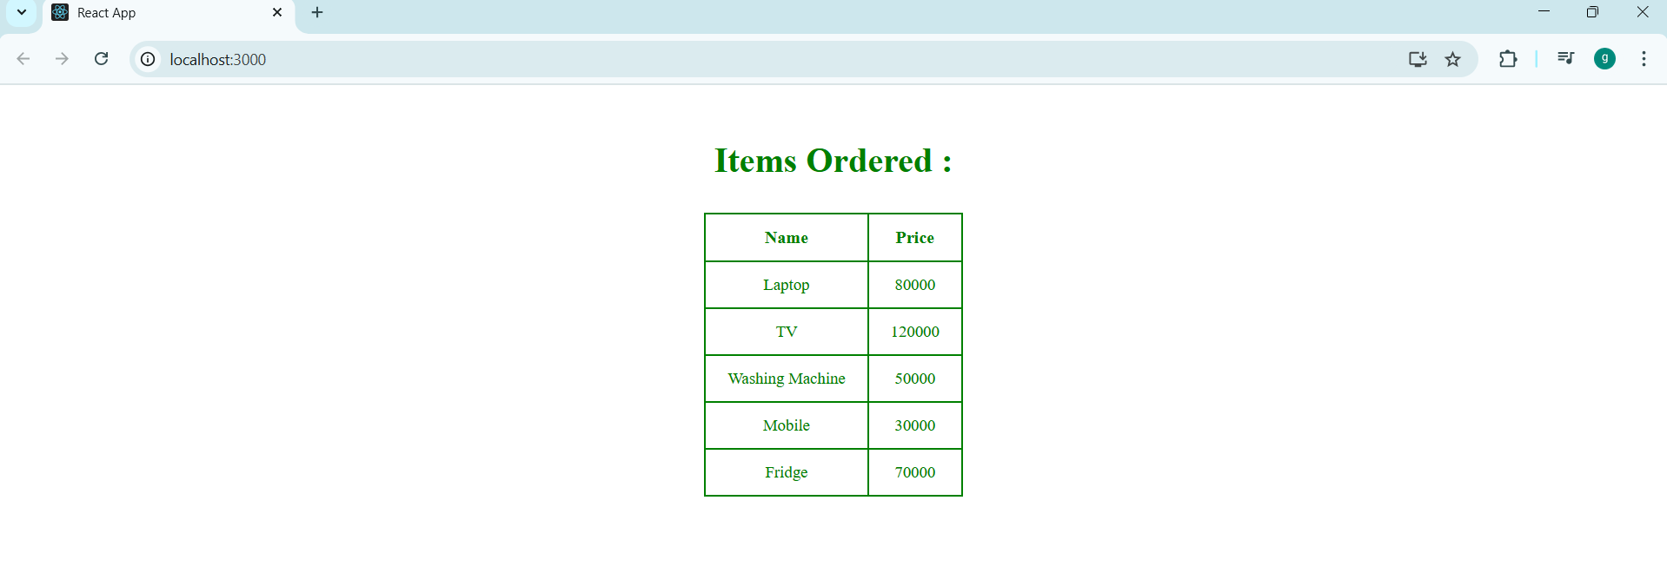

**Hands on 8:**

**Create a React App “counterapp” which will have a component named “CountPeople” which will have 2 methods.**

**UpdateEntry() à which will display the number of people who entered the mall.**

**UpdateExit() à which will display the number of people who exited the mall.**

**Use Constructor and state to Store the entrycount and exitcount.**

**The component has 2 buttons**

1. **Login à when clicked, the entrycount should get incremented by 1**
2. **Exit à when clicked, the exitcount should get incremented by 1**

**Step 1: Create counterapp using command npx create-react-app counterapp**

**Step 2:**

**Modify react.js as below:**

import React from "react";

class CountPeople extends React.Component {

constructor(props) {

super(props);

this.state = {

entryCount: 0,

exitCount: 0

};

}

UpdateEntry = () => {

this.setState((prevState) => ({

entryCount: prevState.entryCount + 1

}));

};

UpdateExit = () => {

this.setState((prevState) => ({

exitCount: prevState.exitCount + 1

}));

};

render() {

return (

<div style={styles.container}>

{/* Row 1: Login button and entry count */}

<div style={styles.row}>

<button onClick={this.UpdateEntry} style={styles.button}>

Login

</button>

<span style={styles.message}>

{this.state.entryCount} People Entered!!!

</span>

</div>

<div style={styles.row}>

<button onClick={this.UpdateExit} style={styles.button}>

Exit

</button>

<span style={styles.message}>

{this.state.exitCount} People Left!!!

</span>

</div>

</div>

);

}

}const styles = {

container: {

display: "flex",

justifyContent: "center",

flexDirection: "column",

alignItems: "center",

marginTop: "100px",

fontFamily: "Arial"

},

row: {

display: "flex",

alignItems: "center",

marginBottom: "20px"

},

button: {

backgroundColor: "green",

color: "white",

border: "1px solid green",

padding: "6px 12px",

borderRadius: "4px",

fontWeight: "bold",

cursor: "pointer",

marginRight: "10px"

},

message: {

fontSize: "16px",

color: "black"

}

};

export default CountPeople;

**step 3: Modify index.js app**

import React from 'react';

import ReactDOM from 'react-dom/client';

import CountPeople from './App';

const root = ReactDOM.createRoot(document.getElementById('root'));

root.render(

<React.StrictMode>

<CountPeople />

</React.StrictMode>

);

**Output:**

